OPERATING SYSTEMS AND SYSTEM PROGRAMMING(OSSP)

NAME: K. SHASHANK REDDY
ROLL NO: 2520030215
SEC: 08

SKILL -2

- AIM:To Create Main Loop, Display Prompt, Read User Input, Handle Exit Conditions, Design Control Flow Diagram, Test Interactive Loop
To Capture Keyboard Input, Handle Backspace, Process Enter Key, Manage Input Buffer, Support Multi-Character Commands, Test User Interaction

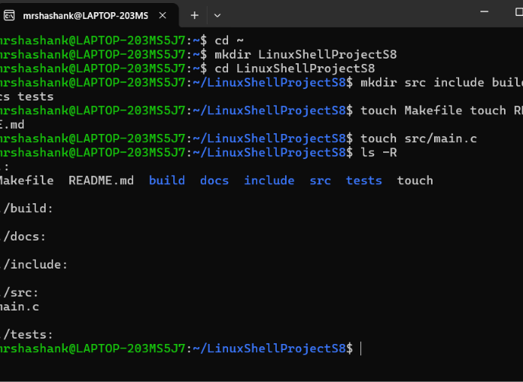

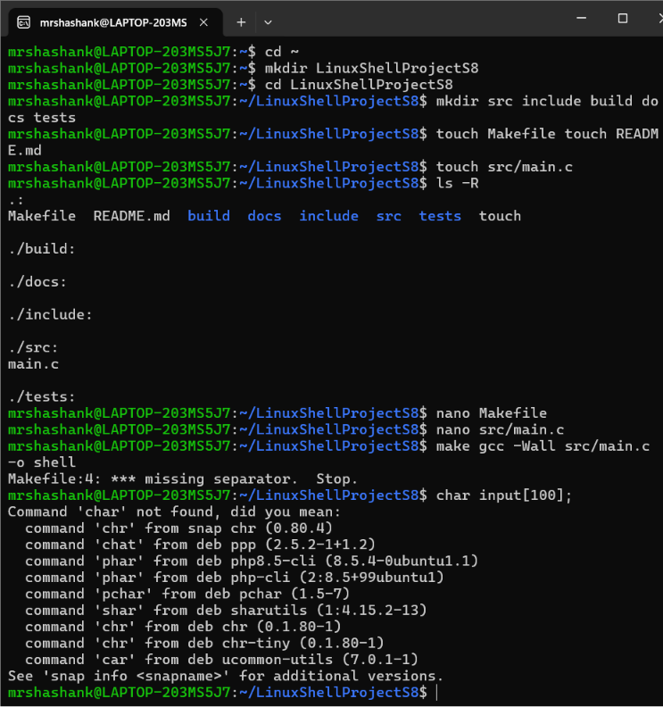

CODE:

